Cybersecurity Analyst Internship
Task Report

[samfelix15@gmail.com]
Task No: [21 - Introduction To SIEM Tools]

Copyright © 2024 EncryptEdge Labs. All rights reserved
Credit: Offensive Security

Table of Contents
1.0 EncryptEdge Labs Internship Task Report 2
1.1 Introduction 3
1.2 Objective 4
1.3 Requirements 5
2.0 High-Level Summary 9
2.1 Recommendations 9
2.2 Risk exposure over time 10
3.0 Report - Methodologies 10
3.1 Information Gathering 11
4.0 Additionals Item X

1.0 EncryptEdge Labs Internship Task Report
1.1 Introduction
.
SIEM originated from log management, evolving into a comprehensive security solution. The concept of SIEM was first coined by Gartner in a 2005 IT security report. Initially, organizations relied on firewalls for network security, but as network traffic grew, firewalls became less effective due to limited visibility into network data.
The early 1990s saw the emergence of commercial intrusion detection systems (IDSes), which laid the groundwork for SIEM. These systems identified potential security risks by centralizing and analyzing event data across IT environments. However, first-generation SIEM systems had limitations, including poor scalability and manual intervention requirement.
Security Information and Event Management (SIEM) tools are designed to collect, analyze, and respond to security events within an organization's IT environment. These tools provide real-time threat detection, incident response, and compliance management, helping organizations protect themselves from cyber threats

1.2 Objective
The primary objectives of implementing a SIEM tool inv Enterprise Security are:
1. Improve Threat Detection: Enhance the organization's ability to detect and respond to security threats in real-time.
2. Enhance Incident Response: Streamline incident response processes, reducing the impact of security incidents.
3. Ensure Compliance: Meet regulatory compliance requirements through automated reporting and auditing capabilities.
4. Provide Visibility: Offer a centralized view of security events across the organization, enabling better decision-making.
Based on this report, my main objectives is to
Familiarize yourself with the core functionalities of SIEM tools and their role in data analysis and threat detection.
Learn to ingest and normalize data from different sources within a network.
Set up alerts and reports to monitor security events effectively.

1.3 Requirements
To implement Splunk(S I E M) Enterprise Security effectively, organizations should:
1.Define Security Requirement: Clearly outline the organization's security requirements and objectives.
2.Configure Data Sources: Configure data sources to collect and analyze security data from various IT environments.
3.Implement Real-time Monitoring*: Set up real-time monitoring and alerting capabilities to detect and respond to security threats.
4. Provide Training: Provide training to security teams to ensure they can effectively use the tool.
With regards to this report, I am obliged to
A short report explaining why you selected the specific SIEM tool.
A screenshot of the tool installed and configured in your environment, along with documentation of the setup process.
A brief report on the data sources used and screenshots of successful data ingestion and normalization.
A summary report detailing your findings from the analysis of security events. Include screenshots of the analysis process.
A report containing details of the alerting configuration and sample reports generated by the SIEM tool. Include screenshots of the alerting and reporting processes.
In this report we are going to use SPLUNK as our experimental SIEM tools to carry out our objectives.

Choosing a SIEM Tool: Splunk Enterprise Security
SIEM has become a crucial tool for organizations to detect, analyze, and respond to security events. Its evolution continues, with advancements in AI, machine learning, and SOAR (Security Orchestration, Automation, and Response) breathing new life into this technology.
Splunk offers several advantages over other Security Information and Event Management (SIEM) tools. Here's a detailed explanation of its benefits

Key Advantages Of Splunk
Splunk offers several advantages over other Security Information and Event Management (SIEM) tools. Here's a detailed explanation of its benefits:
Robust Log Analysis: Splunk excels at analyzing logs from various sources, providing real-time insights into security events across all environments. Its powerful analytics engine collects and analyzes data, enabling organizations to detect and respond to threats effectively. Splunk's log analysis capabilities include:
Data Ingestion: Collecting data from various sources, including logs, network traffic, and system events.
Data Parsing Parsing and normalizing data to make it searchable and analyzable.
Data Analysis: Analyzing data using advanced analytics and machine learning techniques to identify patterns and anomalies.
Scalability and Customization: Splunk scales up to match growing requirements without compromising performance. Its architecture allows customization for various use cases, including:
Custom Dashboards: Creating custom dashboards to visualize data and provide real-time insights.
Personalized Filters: Creating personalized filters to focus on specific data sets and reduce noise.
Tailored Severity Score: Creating tailored severity scores to prioritize threats based on risk.
Real-time Monitoring: Splunk provides real-time monitoring, facilitating faster identification and rectification of issues. It detects anomalies and anticipates potential security threats based on patterns in data. Splunk's real-time monitoring capabilities include
Real-time Alerts: Generating real-time alerts based on predefined conditions and thresholds.
Anomaly Detection: Detecting anomalies and unusual patterns in data to identify potential security threats.
Predictive Analytics: Using predictive analytics to anticipate potential security threats and prevent incidents.
Extensive Integrations: With over 2,300 integrations, Splunk works seamlessly with various data sources, including:
Cloud Platform: Integrating with cloud platforms like AWS, Azure, and Google Cloud Platform.
Security Tools: Integrating with security tools like firewalls, intrusion detection systems, and antivirus software.
IT Systems: Integrating with IT systems like servers, databases, and applications.
Automated Risk-Based Alertin: Splunk's automated risk-based alerting system prioritizes threats, reducing noise and helping analysts focus on serious threats. This feature includes:
Risk Scoring: Assigning risk scores to threats based on their potential impact and likelihood. Alert Prioritization: Prioritizing alerts based on risk scores to ensure that analysts focus on the most critical threats.
User-Friendly Interface: Splunk's interface is intuitive and easy to navigate, with self-explanatory navigation and engaging graphics. The interface includes Customizable Dashboards Customizable dashboards to visualize data and provide real-time insights.
Search and Filtering: Powerful search and filtering capabilities to quickly identify specific data sets.
Visualization: Visualization capabilities to present data in a clear and concise manner.

Types of SIEM Tools
Some popular SIEM tools include:
Splunk Enterprise Security: A powerful analytics engine for in-depth security data analysis, real-time threat detection, and user behavior analytics. It's highly customizable and suitable for large organizations with complex security requirements.
LogRhythm SIEM: Offers pre-built security content, incident response, and security orchestration, automation, and response (SOAR) capabilities. It's ideal for mid-sized businesses and provides real-time security insights.
Elastic Security (ELK Stack): An open-source SIEM platform based on Elasticsearch, offering real-time threat detection, log management, and scalability. It's suitable for organizations with internal security knowledge and provides customizable solutions.
Comparison to Other SIEM Tools
IBM QRadar : While QRadar is easier to deploy, Splunk offers more integrations and a better user interface. QRadar's user interface can feel outdated, and its modules may seem cobbled together.
Microsoft Sentine: Sentinel excels in cloud-native enterprises, offering more features without extra charges for automation. However, Splunk's flexibility and scalability make it suitable for organizations with diverse IT environments.
Additional Benefits
Supportive Community: Splunk's community collaborates to enhance the tool's utility and comprehensiveness, providing learning resources and forums.
Free Trial and Training: Splunk offers a 60-day free trial and over 50 free training courses, helping organizations get started and maximize the tool's potential.
Flexibility: Splunk can be deployed in various environments, including cloud, on-premises, and hybrid architectures.
Modern SIEM
Today, SIEM solutions offer advanced features such as:
Log Management: Collecting and managing log data from various sources
Real-time Monitoring: Analyzing network flows to detect malicious behavior
Event Detection: Correlating logs and data to identify known indicators of compromise
Threat Intelligence: Incorporating open-source and commercial threat intelligence feeds
2.0 High-Level Summary
Splunk Enterprise Security is a powerful SIEM tool that offers real-time threat detection, user behavior analytics, and compliance reporting. Its highly customizable solutions make it an ideal choice for large organizations with complex security requirements. By implementing Splunk Enterprise Security, organizations can improve threat detection, enhance incident response, ensure compliance, and provide visibility into security events.
Overall, Splunk Enterprise Security is a powerful SIEM solution that helps organizations detect, investigate, and respond to security threats in real-time, while also providing compliance management and incident response capabilities
Security Information and Event Management (SIEM) has a rich history spanning over two decades.
Around 2015, SIEM tools began integrating machine learning and AI, enabling them to evaluate network traffic against known attacks and generate alerts. The arrival of low-cost, scalable storage solutions like Apache Hadoop and Amazon S3 also improved SIEM's correlation and interpretation capabilities ¹.

2.1 Recommendations
Based on its powerful analytics engine, real-time threat detection, and user behavior analytics, I highly recommend Splunk Enterprise Security for large organizations with complex security requirements. Its highly customizable solutions make it an ideal choice for organizations that need to tailor their SIEM tool to specific security needs
Splunk Enterprise Security is a comprehensive Security Information and Event Management (SIEM) solution designed to provide organizations with real-time threat detection, incident response, and compliance management. Here's a breakdown of its vital features and benefits:

2.2 Risk Exposure over Time
Organizations that don't implement a SIEM tool like Splunk Enterprise Security are at risk of:
Security Breaches: Undetected security breaches can lead to data loss, financial losses, and reputational damage.
Compliance Issues: Failure to meet regulatory compliance requirements can result in fines and penalties.
Reputational Damage: Security incidents can damage an organization's reputation and erode customer trust.

3.0 Methodologies
To implement Splunk Enterprise Security, organizations should follow a structured methodology:
1. Planning: Define security requirements, identify data sources, and determine the scope of the implementation.
2. Configuration: Configure data sources, set up real-time monitoring, and customize the tool to meet specific security needs.
3. Testing: Test the implementation to ensure it's working correctly and detect any potential issues.
4. Deployment: Deploy the tool to production environments and provide training to security teams.

3.1 Information Gathering
Splunk Enterprise Security gathers information from various IT environments, including:
Network Devices: Firewalls, routers, and switches.
Servers: Physical and virtual servers.
Applications: Web applications, databases, and other software applications.
User Activity: User login activity, file access, and other user behavior.

Integration and Scalability
Integration with Other Tools: Splunk ES integrates with other security tools, such as Symantec Endpoint Protection and McAfee Endpoint Protection, to provide a comprehensive security solution.
Scalability: The solution can handle hundreds of terabytes of data daily, making it suitable for large organizations with complex security requirements

4.0 Additional Items
Below will include screenshots of completed lab assignments which includes
- Introduction To SIEM
- Exploring Splunk

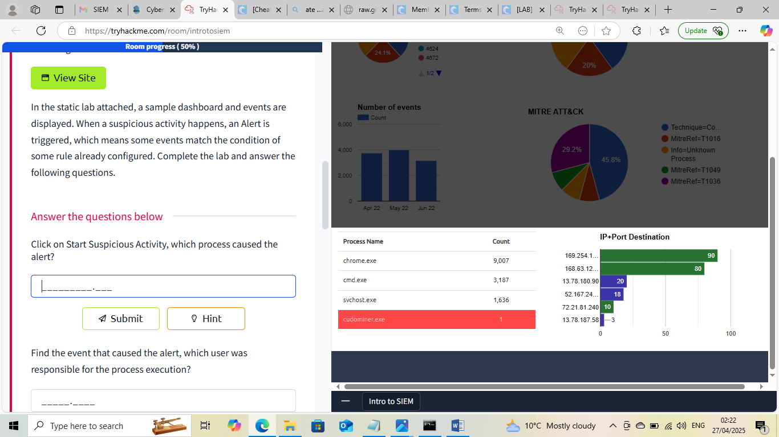

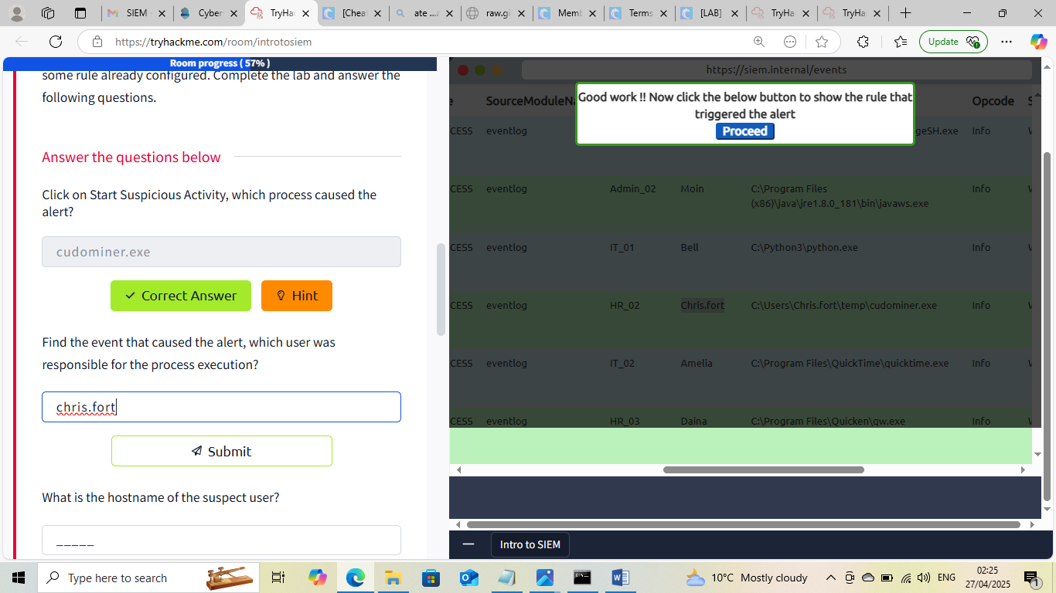

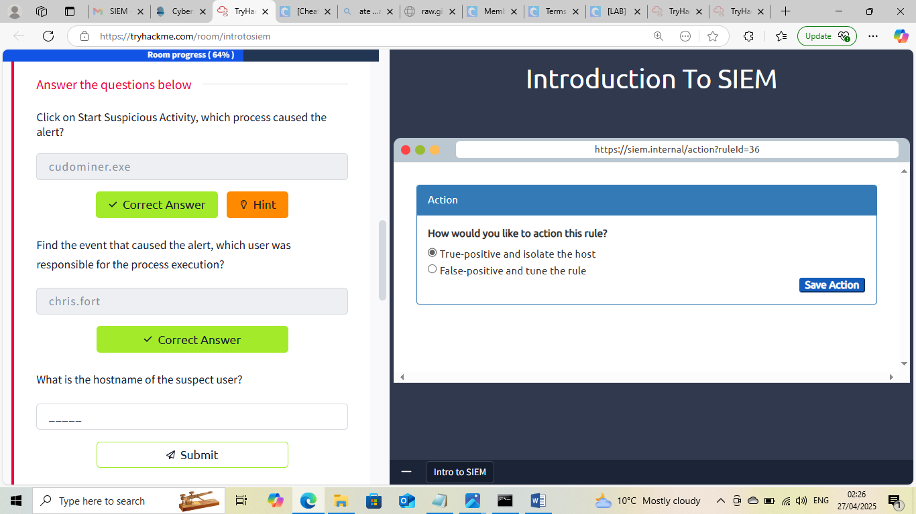



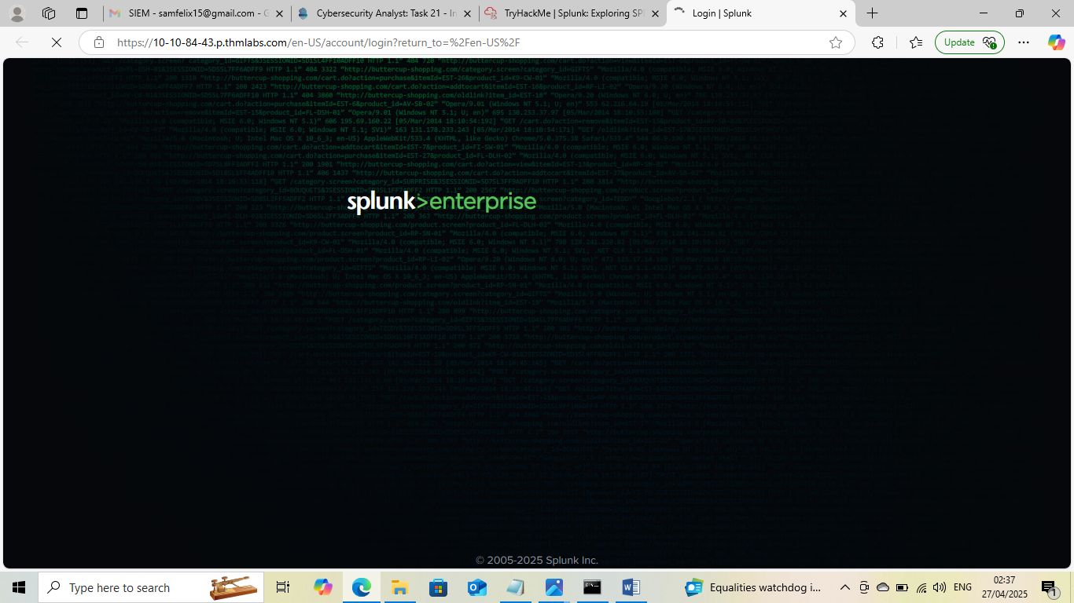

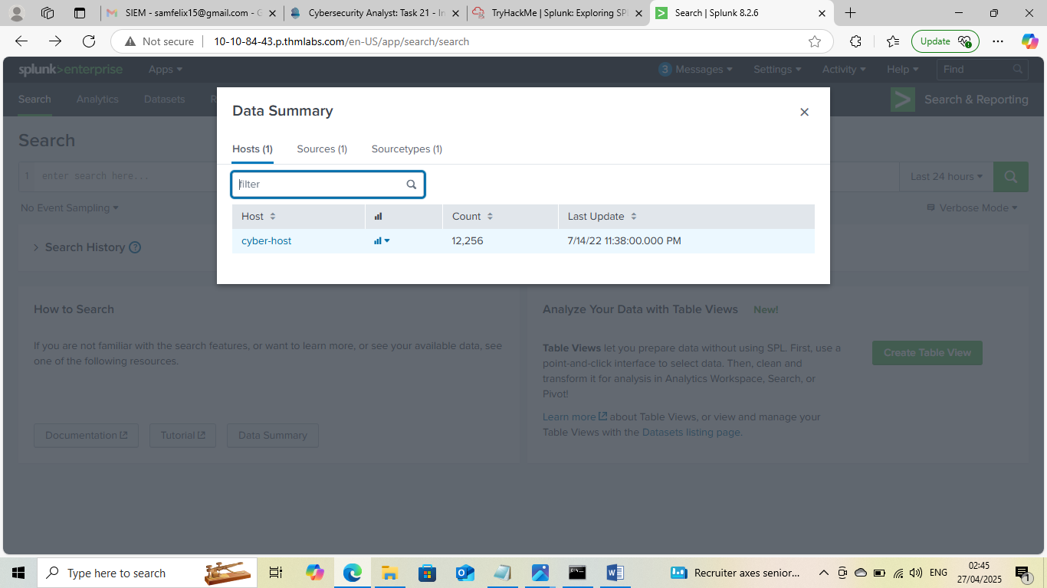

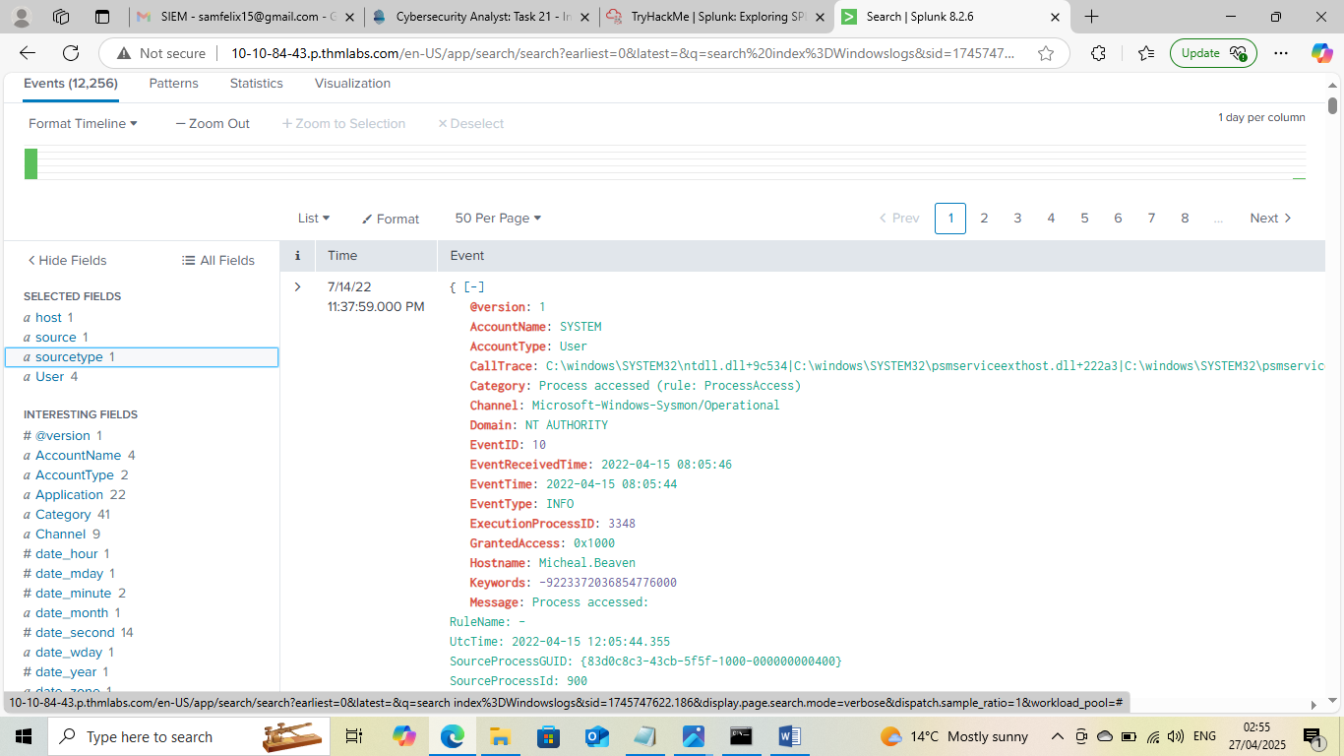
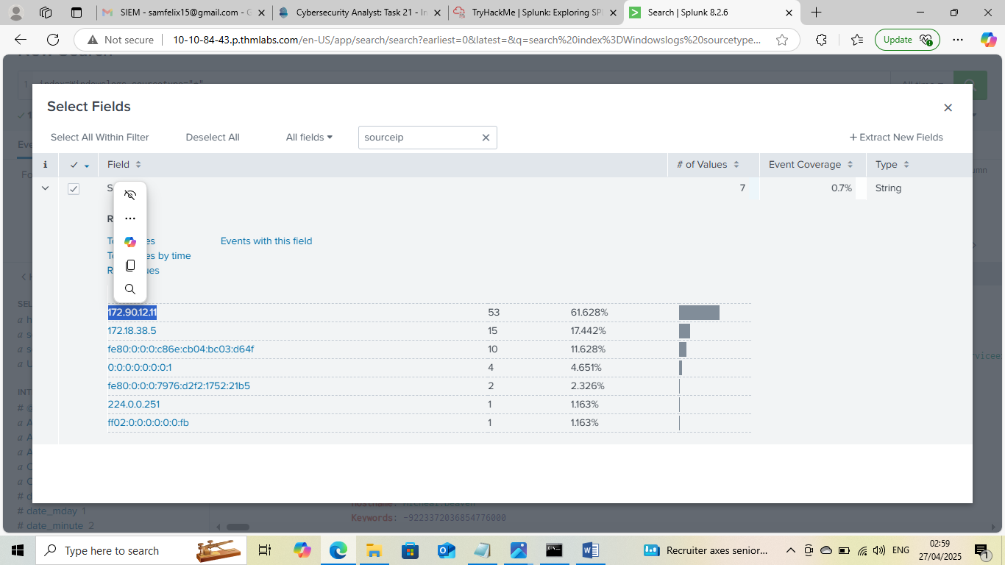

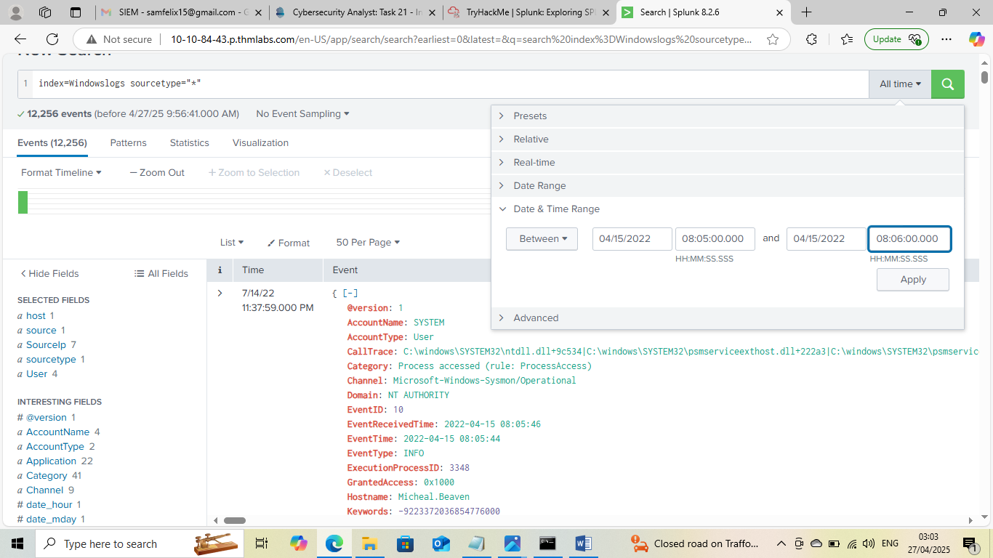
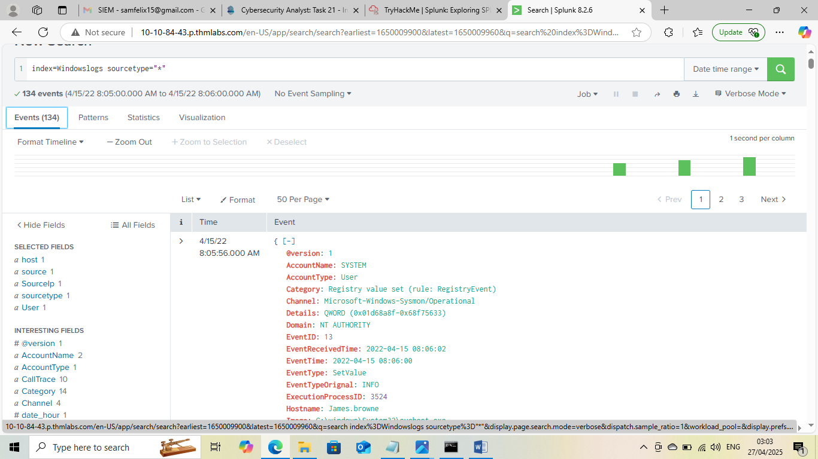

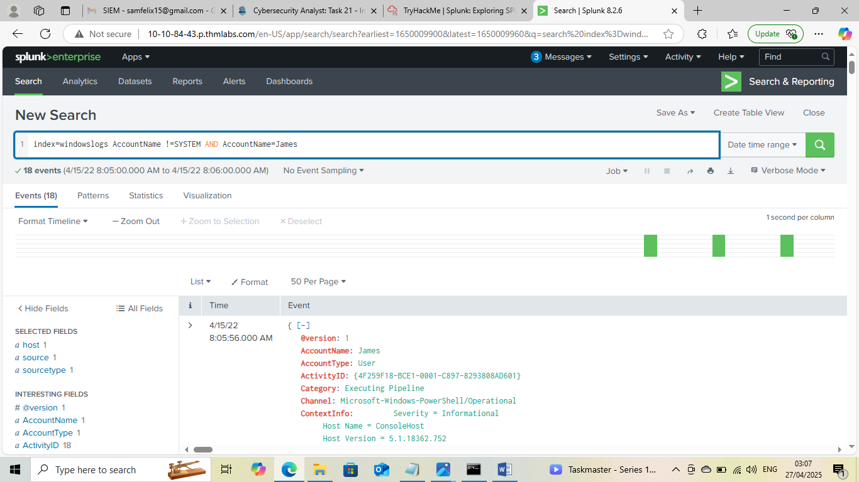
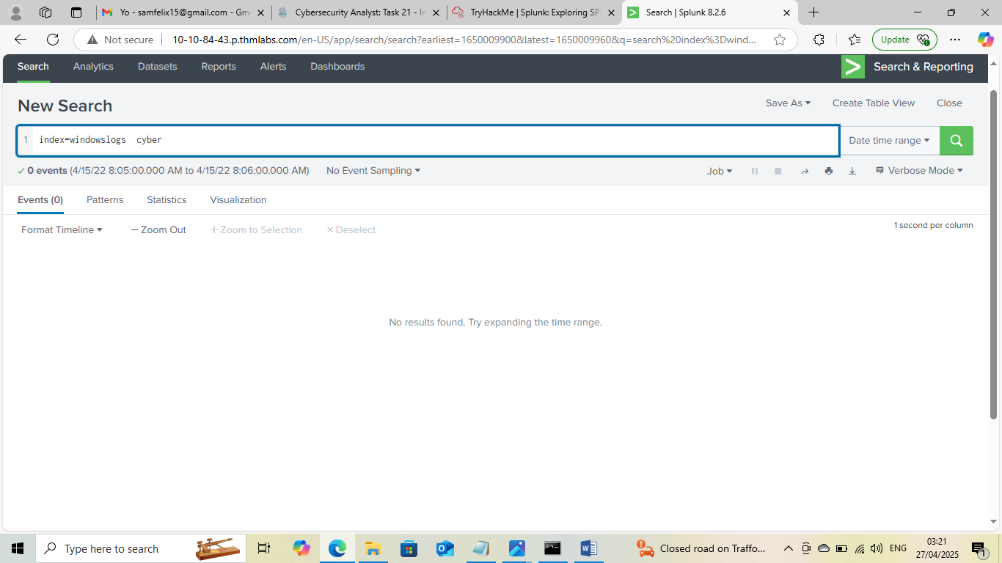

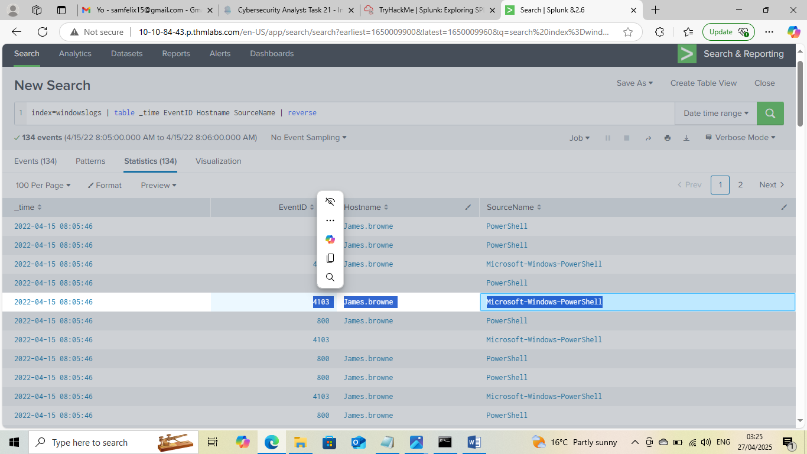
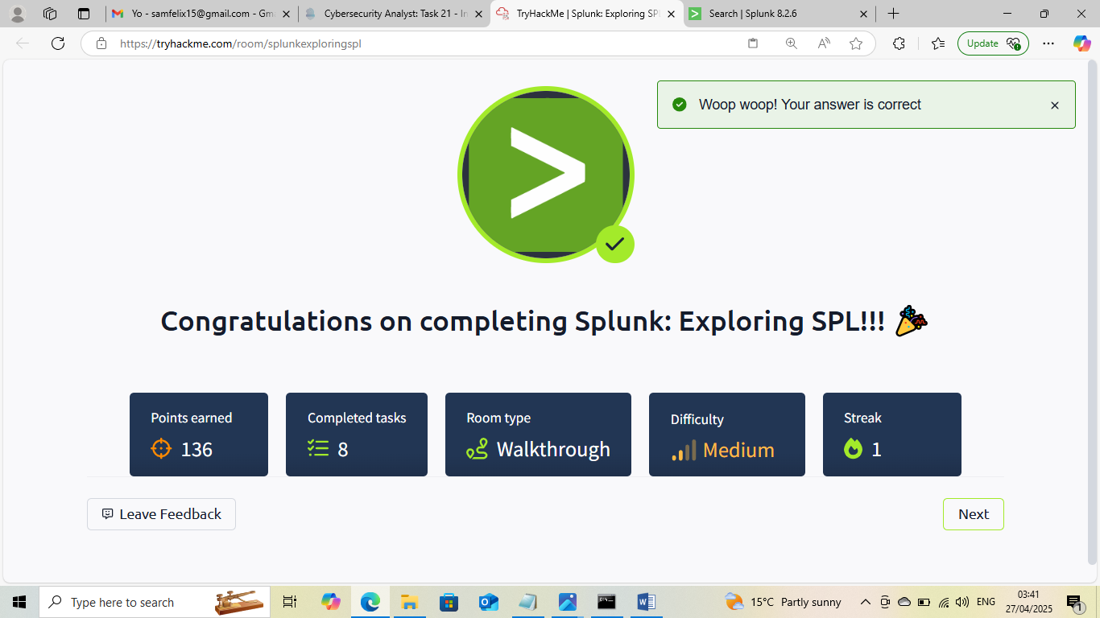

This Internship Task report was developed on [April, 27, 2025]

By:
[ samfelix15@gmail.com ]

